**Ss.1.1 Assigment-1 Change Password**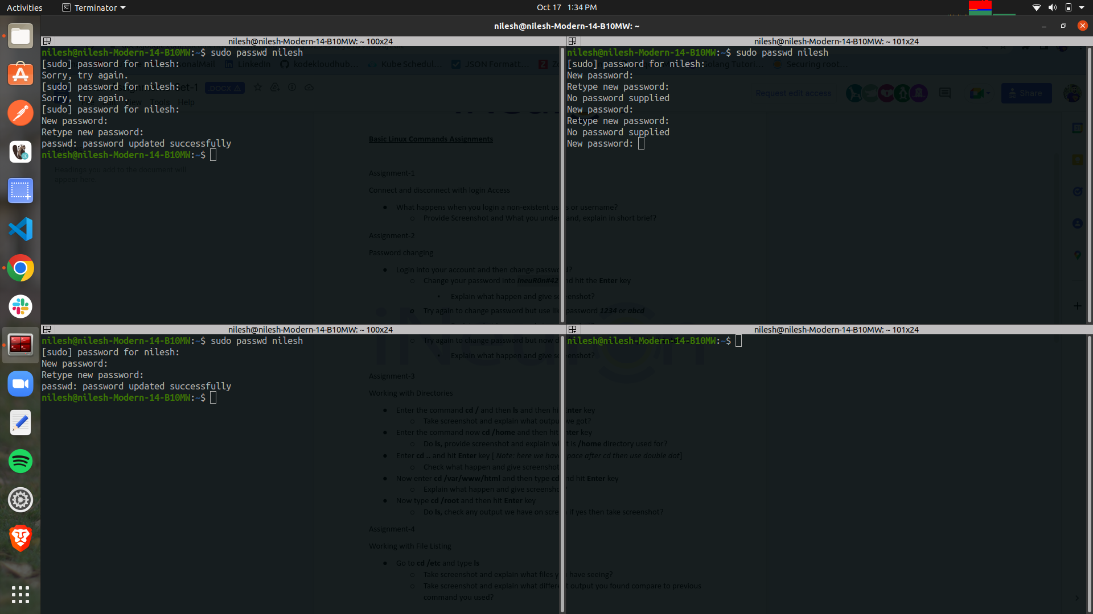

* First window and second window password change successfully
* Third window when we change password with enter keyword it cant accept for Enter keyword display message that “No Password Supply”

—-----------------------------------------------------------------------------------------------------------------

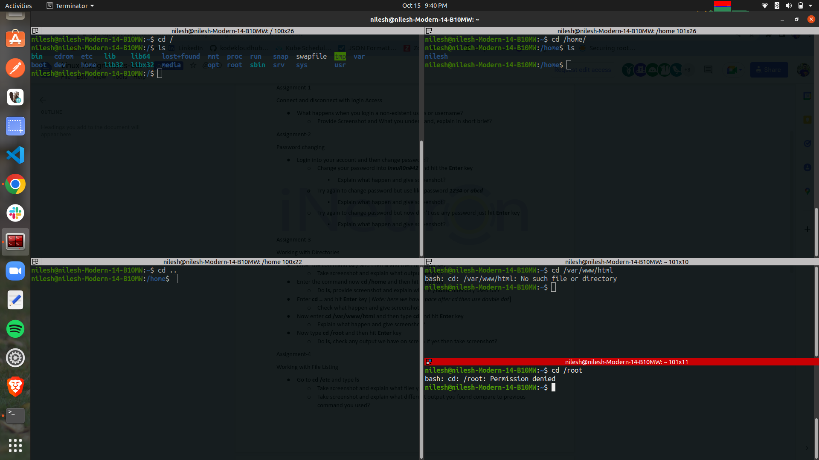

**Ss.1.2 Assigment:-2 Working with Directories**

* First window when type **cd** it will change directory at last when do **ls** after that it will show us list of files and directories .
* In second window when we do **cd /home** it will change directory to home after thatwhen we do **ls** it will show list of files and folders in home directory
* In third window when we d**o cd ..** it will take us to home directory where are you when we type **cd ..** it change directory to home directory
* In fourth window when we type **cd /var/www/html** it will take us in in that particular path in that we dont have any web server in system so it will show us no such file and directory is found showing
* In fifth window if type **cd /root** it will show us we don’t have permission for that if type this command with **sudo cd /root** privileges then it will take us in root directory and when we do ls for there it will show us list of files and directories of in that directories

**—----------------------------------------------------------------------------------------------------------------------------------------**

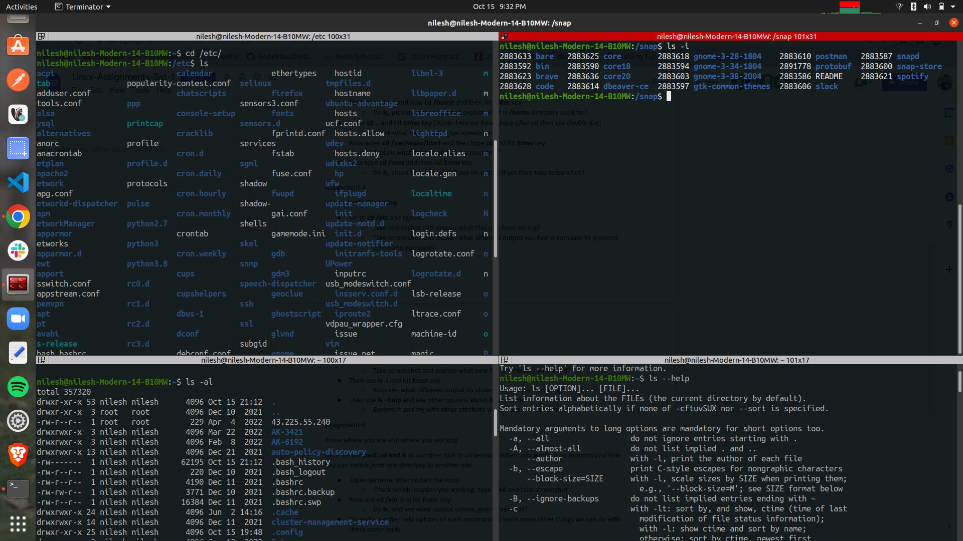

**Ss1.3 Assigment:-4 Working with File Listing**

* In first window will change the current directory to "/etc" - i.e. the etc directory in the root (or /) directory.
* When do **ls** in /**etc** directory its shows us all linux configuration file live the system
* In the second window ls -al The option '-l' tells the command to use a long list format. It gives back several columns wich correspond to

Permissions

Number of hardlinks

File owner

File group

File size

Modification time

Filename

The first letter in the permissions column show the file's type. A 'd' means a directory and a '-' means a normal file (there are other characters, but those are the basic ones). The next nine characters are divided into 3 groups, each one a permission. Each letter in a group correspond to the read, write and execute permission, and each group correspond to the owner of the file, the group of the file and then for everyone else.

[ File type ][ Owner permissions ][ Group permissions ][ Everyone permissions ]

The characters can be one of four options:

r = read permission

w = write permission

x = execute permission

- = no permission

Finally, the "+" at the end means some extended permissions.

* In third window **ls -i** it display **inode** numbers of files and directories
* In forth window **ls - -help** to view more options with ls we use this command

—-----------------------------------------------------------------------------------------------------------------------

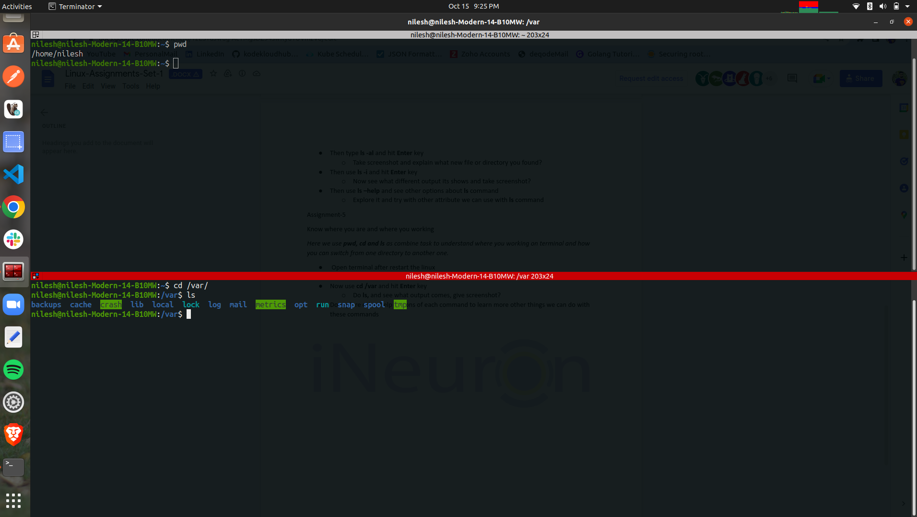

**Ss1.4 Assigment:-5 Know where you are and where you working**

* In first window after **pwd** command its show us present working directory
* **In second window cd /var shows us** contains variable data files. This includes spool directories and files, administrative and logging data, and transient and temporary files. Some portions of /var are not shareable between different systems.